HIGH RODING

PARISH COUNCIL

FINAL ACCOUNTS 2025/2026

Clerk
Bonnie Jones

Financial Summary 2025/2026
We started the year with £27,894.60 in the bank.
The precept set for 2025/2026 was £24,637.
The total income (including precept) for 2025/2026 was £48,728.91. This was against a budgeted income of £25,127 – a difference of ££23,601.91. The difference can be accounted for by way of receipt of a grant from UK National Lottery of £20,000, a one of Community grant from UDC of £1,871.87, and an ECC Locality Grant for £1,200, as well as an additional £166.66 in bank interest. A refund for defibrillator pads of £331.20 was also received from Imperative training.
The total expenditure for 2025/2026 was £32,164.64 (this includes VAT of £1,915.08) versus a budget of £24,259.16 – an overspend of £7,914.64 – thus the Council was overbudget, however there were some significant variances in the budget heading as follows:
- An overspend on Insurance of £76.72 (actual of £637.72 versus a budget of £560). When budgeting this Council estimated for a £40 increase which was similar to previous years, however the cost of Clear Councils Insurance was increased by £77.72.
- An overspend on UDC Skip collection of £682.00. This was due to the fact that both the invoices for 2024 and 2025 were paid in the same financial year.
- An overspend of £1,040.00 on tree works. This was due to the tree survey and works being £800 more expensive than originally budgeted for. Also, an unforeseen expense of £300 was spent on the removal of a dead tree on Little Sears land.
- An overspend of £441.85 on Streetlighting. This overspend was due to an unforeseen expense of £508.94 for the repairs to a the broken Broadfield Streetlight.
- An overspend of £4,643.20 on Playground. This overspend was due to repairs to the zipwire at a cost of £1980.57, the filling of the wetpoor on both the slide and cradle swing at a cost of £1,667 and the purchase of a teen shelter at a cost of £2,180.00.
- There were no budgeted items for any S137 payments. However purchases were made under this heading leading to an overspend of £256.87. This was due to the reimbursement to a Parishioner of £235 for a defibrillator training event as well as a reimbursement of £21.87 to the Clerk for the purchase of decorations for the Remembrance Sunday event.
- An overspend on other payments of £2,191.92. £343.63 of this overspend can be accounted for due to the fact that in 2025/2026 this Council began paying Employers NI due to an increase in the Clerks salary. There were also payments made of £1,500 for poppy pins, £350 for the remembrance Sunday event, £15.60 for reimbursement of flowers for the memorial garden, £30 for printing of leaflets, £30.50 for the purchase of a first aid kit and £55.50 for the purchase of dog bin signs.

The 2025/2026 bank reconciliation is as follows:
CASH BOOK:  Opening Balance 1 April 2025  Add: Receipts in the year  Less: Payments in the year |  | £27,894.60  £48,728.91  (32,164.64)
Closing balance per cash book as at 31 March 2026 |  | £44,458.87

Unity Trust Account 20447216 balance 31 March 2026: £34,148.04
Unity Trust Account 20517353 balance 31 March 2026: £10,310.83

£44,458.87
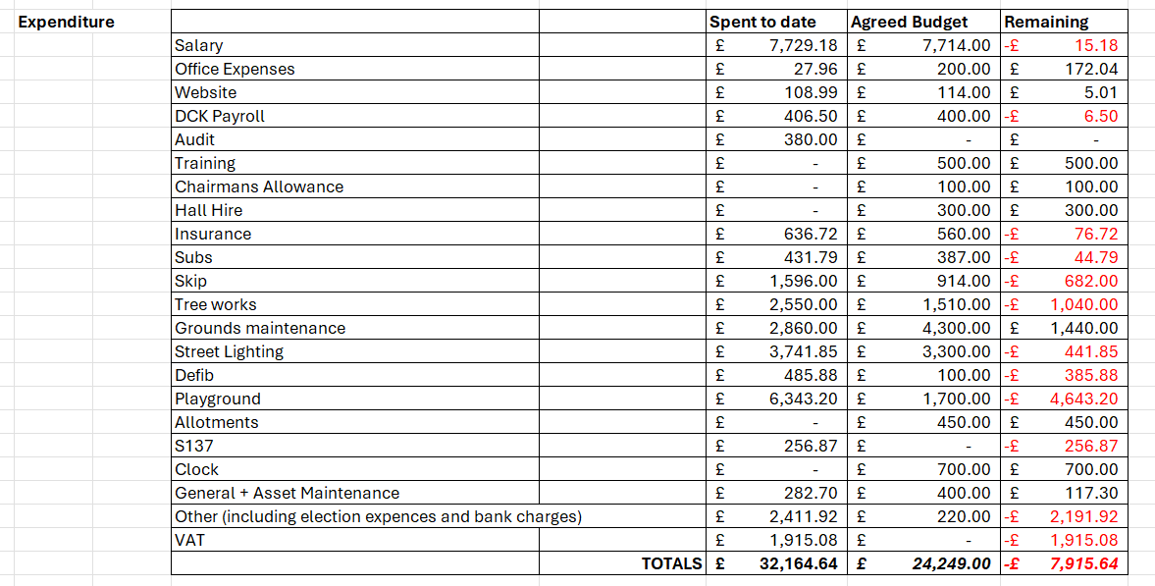
Reserves as at 31st March 2026
Specific Earmarked Funds
 |  | Spent | Remain
Village Clock | 3000.00 |  | 3000.00
Playground | 22248.18 |  | 22248.18
Asset Main | 672.82 | 282.70 | 390.12
Training | 500.00 |  | 500.00
Grounds maintenance | 2140.00 |  | 2140.00
Playarea repairs | 100.00 |  | 100.00
 |  | Total Earmarked | 28,378.30

General Reserves £16,080.57

